What is Test case?
A test case is a document, which has a set of test data, preconditions, expected results and postconditions, developed for a particular test scenario in order to verify compliance against a specific requirement.
Test Case acts as the starting point for the test execution, and after applying a set of input values, the application has a definitive outcome and leaves the system at some end point or also known as execution postcondition.

Typical Test Case Parameters:
- Test Case ID
- Test Scenario
- Test Case Description
- Test Steps
- Prerequisite
- Test Data
- Expected Result
- Test Parameters
- Actual Result
- Environment Information
- Comments

Example:
Let us say that we need to check an input field that can accept maximum of 10 characters.
While developing the test cases for the above scenario, the test cases are documented the following way. In the below example, the first case is a pass scenario while the second case is a FAIL.
Scenario | Test Step | Expected Result | Actual Outcome
Verify that the input field that can accept maximum of 10 characters | Login to application and key in 10 characters | Application should be able to accept all 10 characters. | Application accepts all 10 characters.
Verify that the input field that can accept maximum of 11 characters | Login to application and key in 11 characters | Application should NOT accept all 11 characters. | Application accepts all 10 characters.
If the expected result doesn't match with the actual result, then we log a defect. The defect goes through the defect life cycle and the testers address the same after fix.
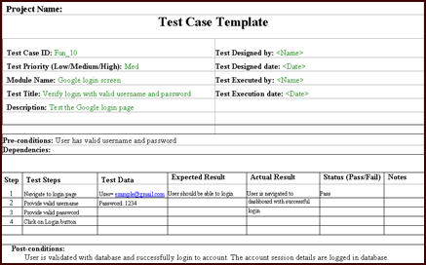

Below are the standard fields of sample test case template:
Test case ID: Unique ID for each test case. Follow some convention to indicate types of test. E.g. ‘TC_UI_1’ indicating ‘user interface test case #1’.
Test priority (Low/Medium/High): This is useful while test execution. Test priority for business rules and functional test cases can be medium or higher whereas minor user interface cases can be low priority. Test priority should be set by reviewer.
Module Name – Mention name of main module or sub module.
Test Designed By: Name of tester
Test Designed Date: Date when wrote
Test Executed By: Name of tester who executed this test. To be filled after test execution.
Test Execution Date: Date when test executed.
Test Title/Name: Test case title. E.g. verify login page with valid username and password.
Test Summary/Description: Describe test objective in brief.
Pre-condition: Any prerequisite that must be fulfilled before execution of this test case. List all pre-conditions in order to successfully execute this test case.
Dependencies: Mention any dependencies on other test cases or test requirement.
Test Steps: List all test execution steps in detail. Write test steps in the order in which these should be executed. Make sure to provide as much details as you can. Tip – to efficiently manage test case with lesser number of fields use this field to describe test conditions, test data and user roles for running test.
Test Data: Use of test data as an input for this test case. You can provide different data sets with exact values to be used as an input.
Expected Result: What should be the system output after test execution? Describe the expected result in detail including message/error that should be displayed on screen.
Post-condition: What should be the state of the system after executing this test case?
Actual result: Actual test result should be filled after test execution. Describe system behavior after test execution.
Status (Pass/Fail): If actual result is not as per the expected result mark this test as failed. Otherwise update as passed.

